**Day 6 - Deployment Preparation and Staging Environment Setup**

**Hosting Platform Setup**

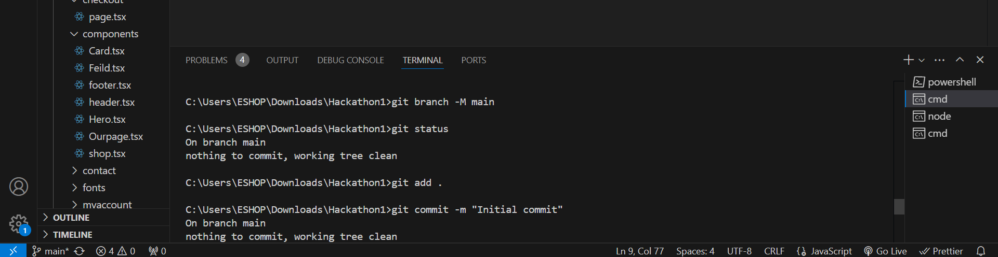

**Hosting Platform Setup**

**Deploy**